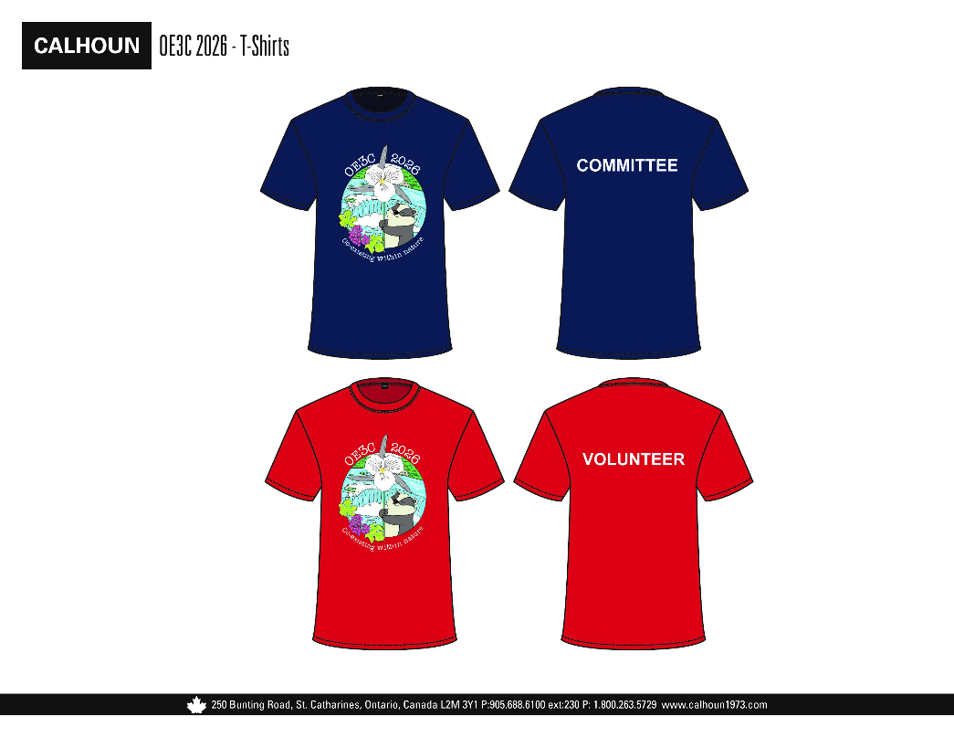
Calhoun Sportswear Retail

Gildan Softstyle Navy T shirts
- front logo/wording on back
- $18/each
- 2XL are an additional $2/each as needed
- Add $2/each for v neck
Gildan Softstyle Red T-shirts
- front logo/wording on back
- $18/each
- 2XL are an additional $2/each as needed
- Add $2/each for v neck

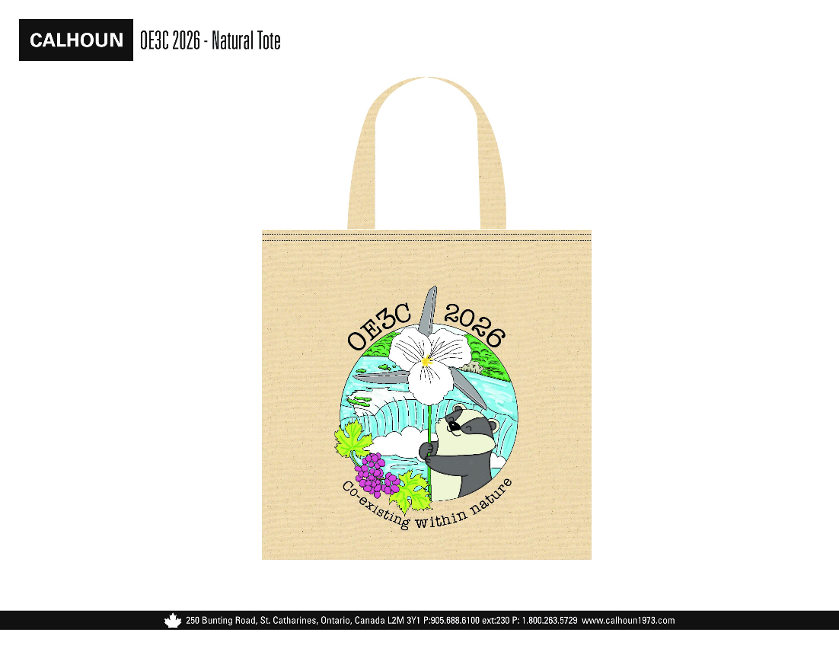
Tote bag:
50 units- $17/each
100 units- $12/each
150 units- $10/each
200 units- $8/each

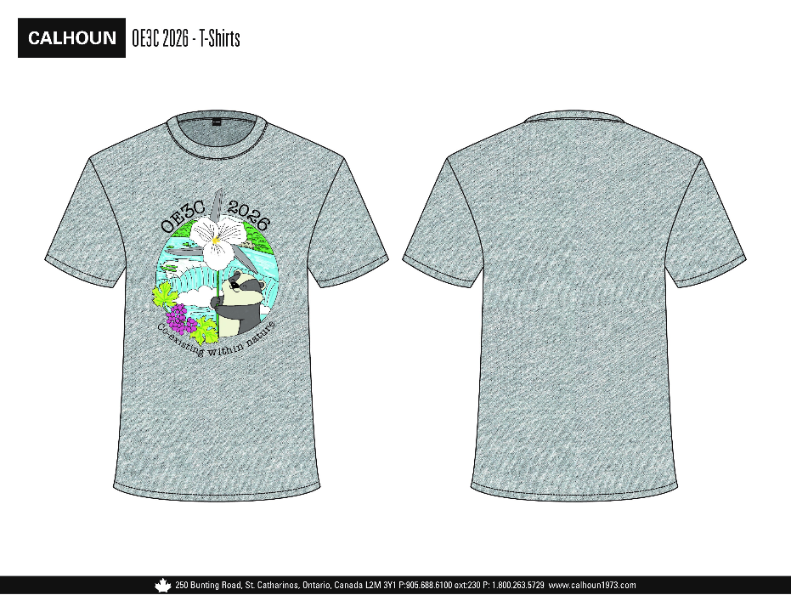
Grey T shirt
- Front print only
- 50 units- $18/each
- 100 units- $13/each
- 150 units- $11/each
- 200 units- $9/each
- 2XL are an additional $2/each as needed

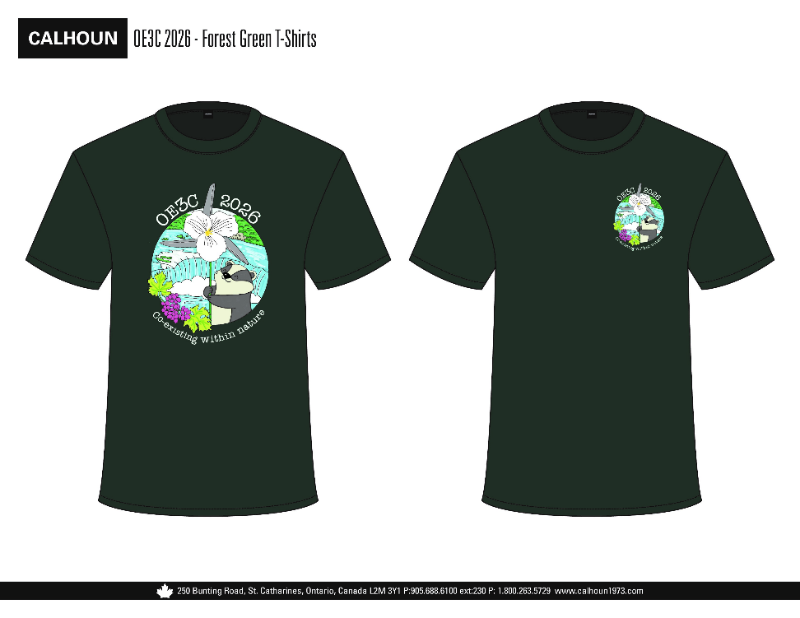
Forest Green T shirt
- Front print only
- 50 units- $18/each
- 100 units- $13/each
- 150 units- $11/each
- 200 units- $9/each
- 2XL are an additional $2/each as needed

